Your starting point here is the completed version of Exercise 6.1. If you already closed that file, please reopen it using the Power BI software. You should first complete the previous exercise before starting with this one. If you just wrapped up the last assignment, your view would probably look like the image below.

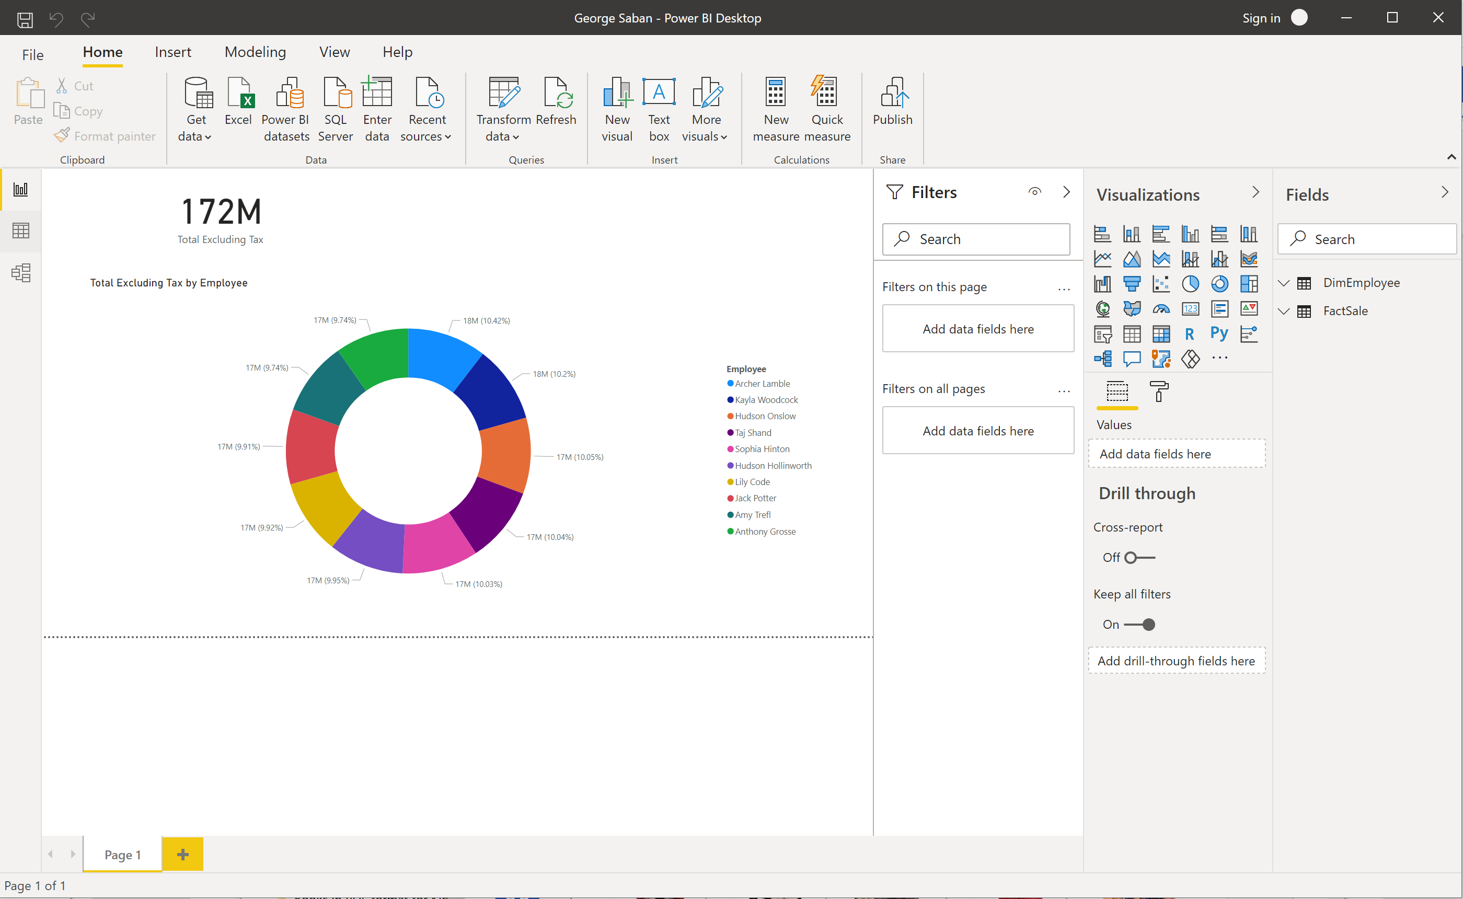

Select the Donut chart, and change the style to Clustered Column Chart.

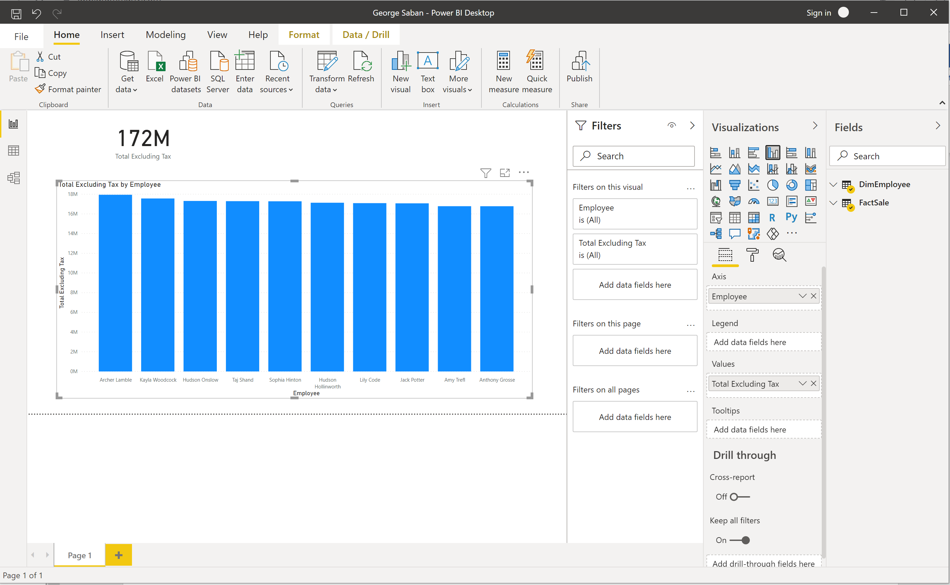

Now, add additional fields. For example, add Profit from FactSale transaction table. Notice how the visualization automatically changed. If the graph did not change, you did not select the bar graph before adding the Profit field. Look at the legend above the bars to interpret the colors.

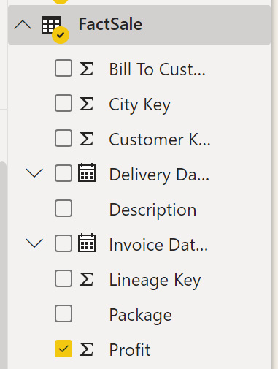 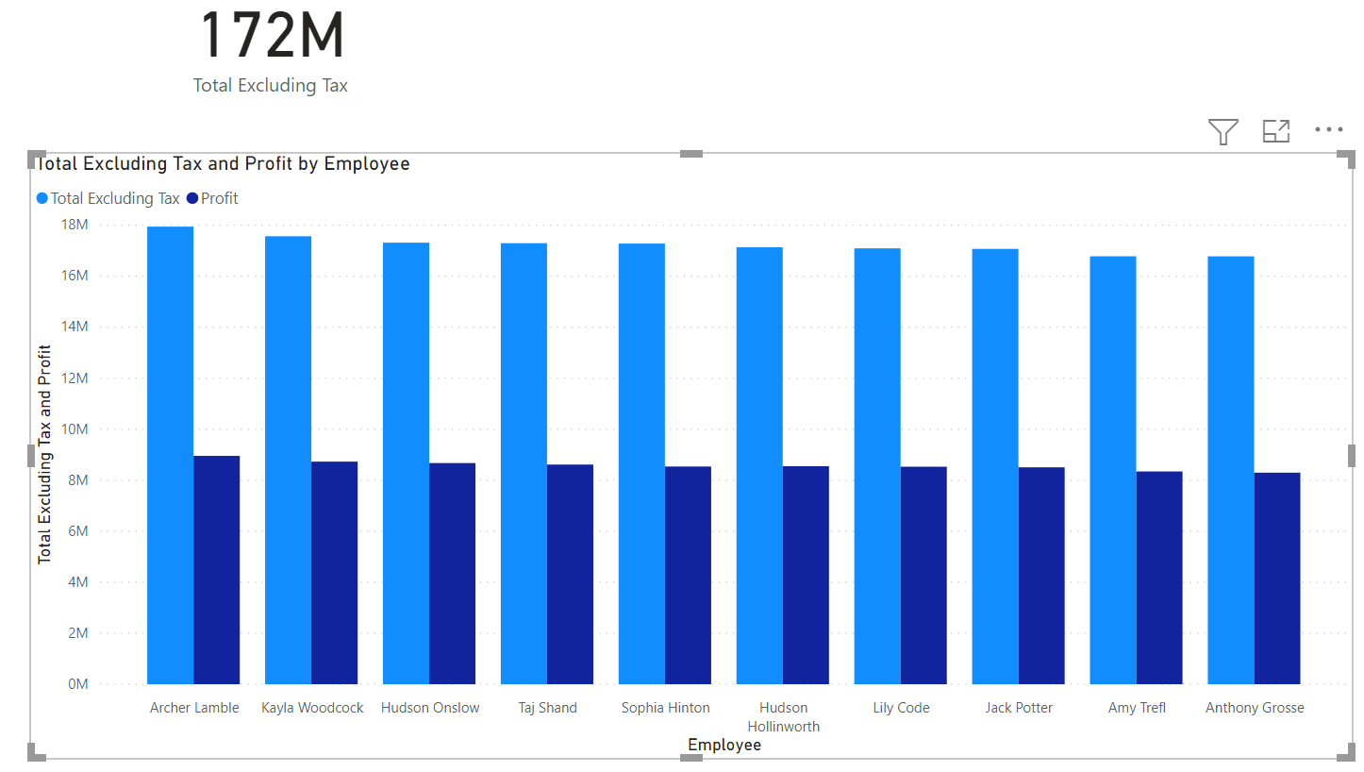



Note that the numerical field has been automatically added in the Values pane.

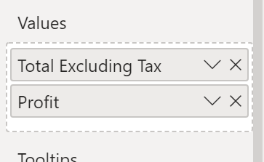



Switch to Data view, and note City Key field in the FactSale table.

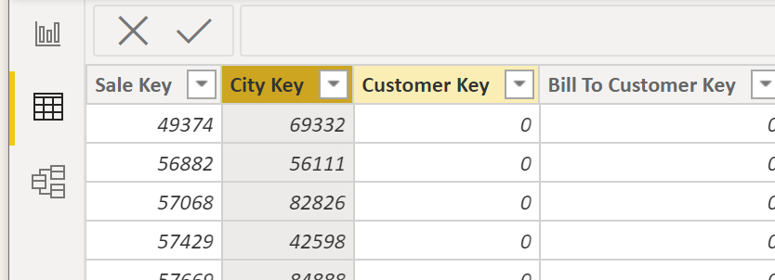v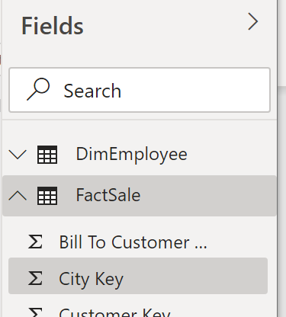



You can see more details about that City by bringing in the DimCity lookup table: Home > Get data > Text/CSV > drill down to find in your local drive DimCity.csv > Open > and do not load yet. This table needs transformation because the field titles are not descriptive.

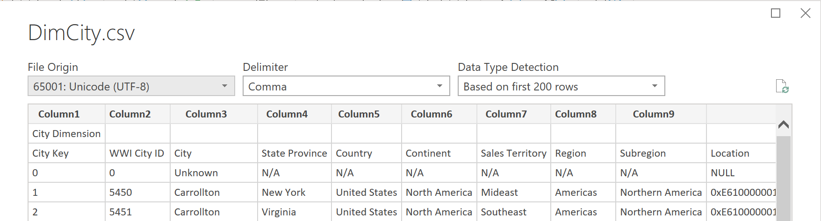



Click Transform Data.

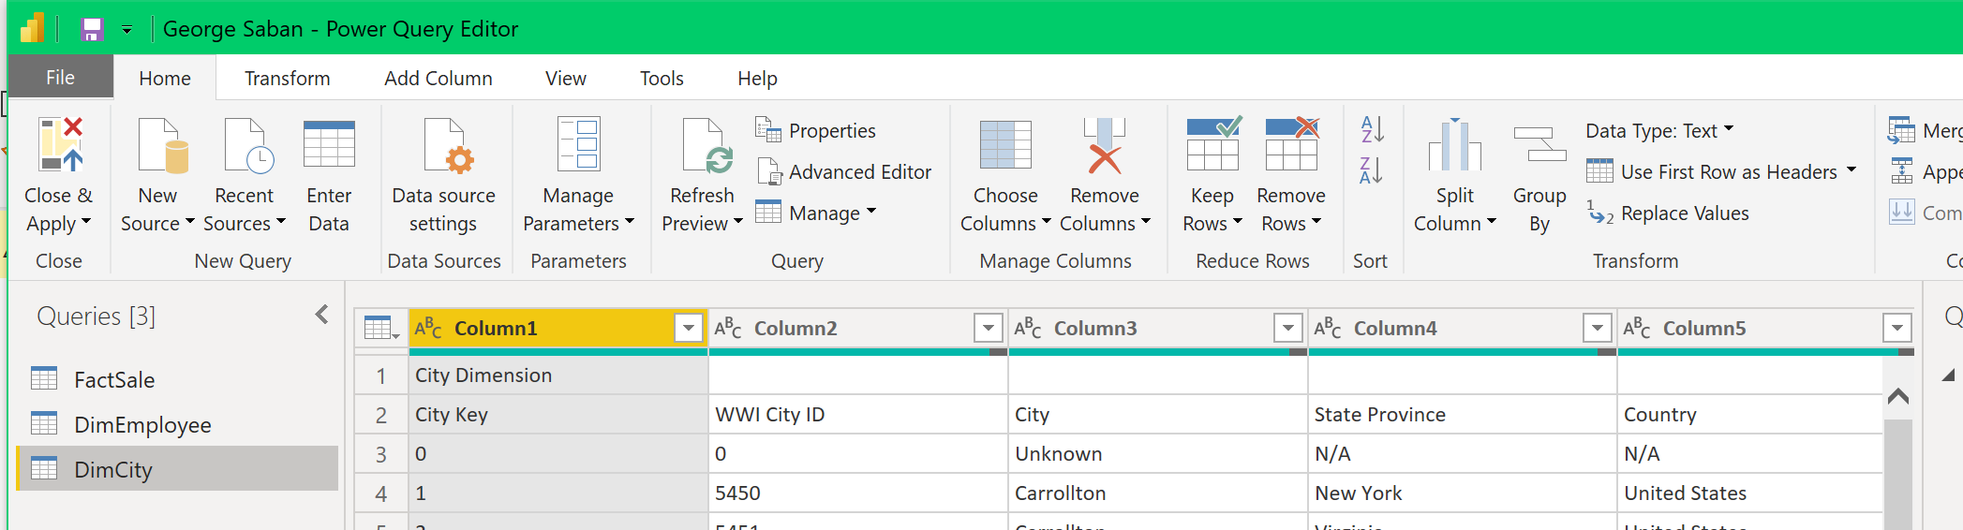

Highlight row 1, and click Remove Rows > Remove Top Row > Number of rows: 1 > OK

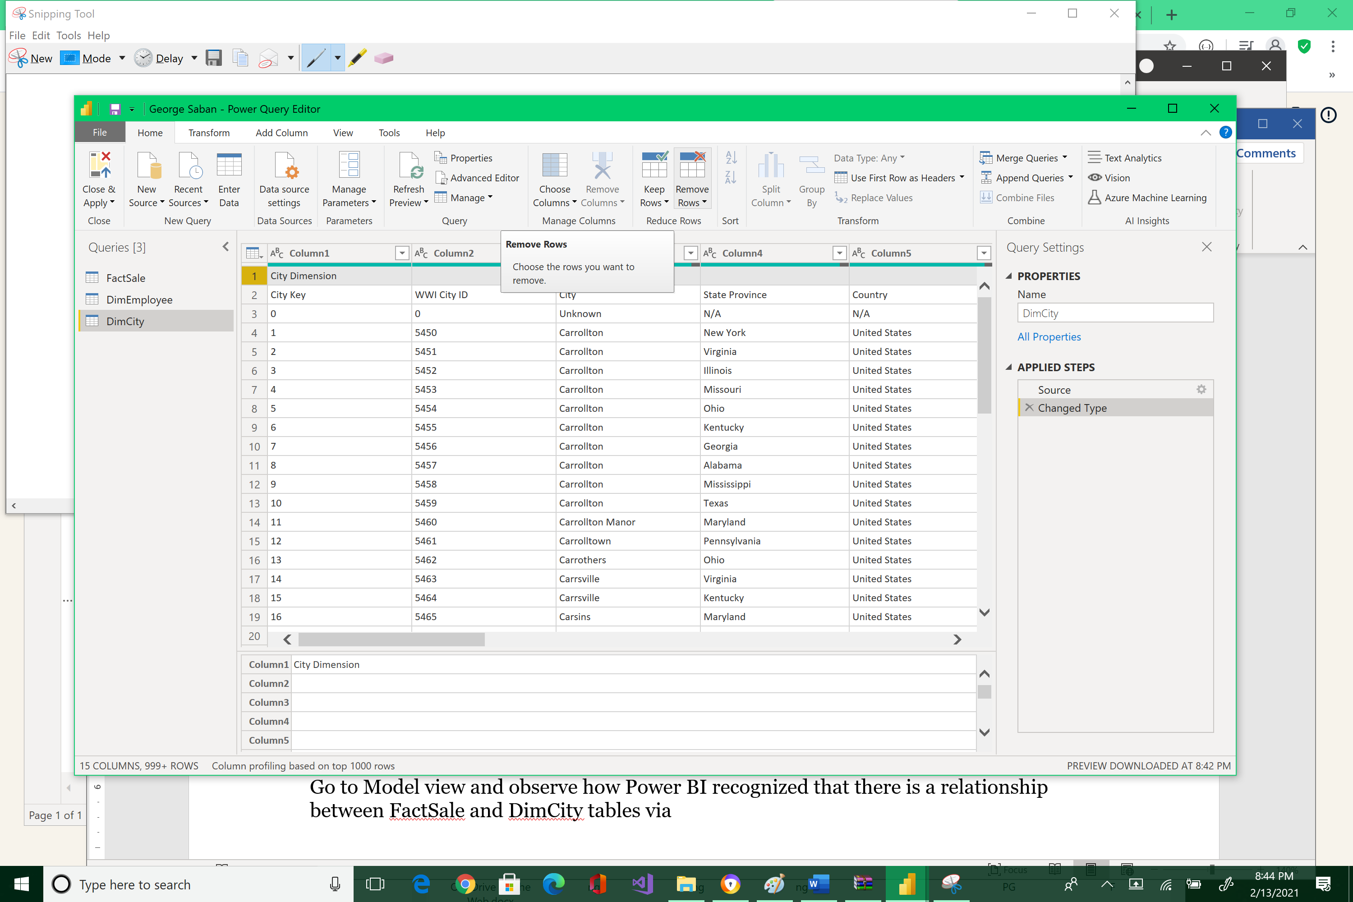



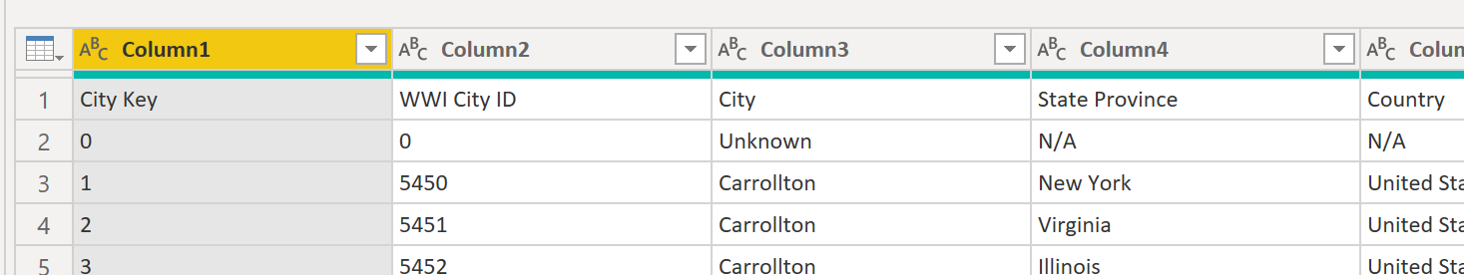

Now promote row 1 as the header:

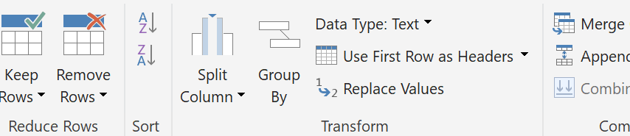



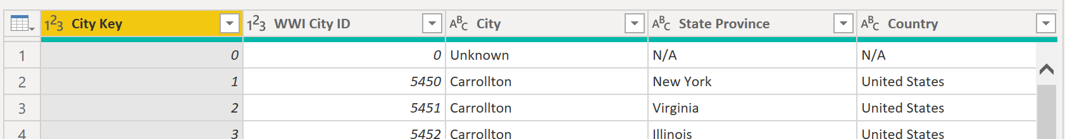

Row 1 is garbage, so highlight it and remove it.

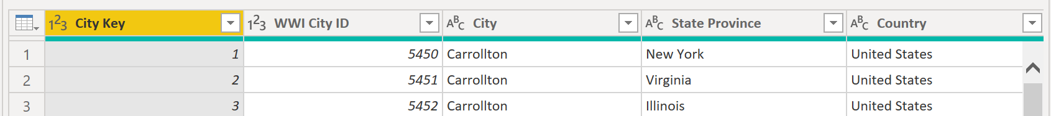

Now the table is clean. Click Close & Apply, then Close & Apply.

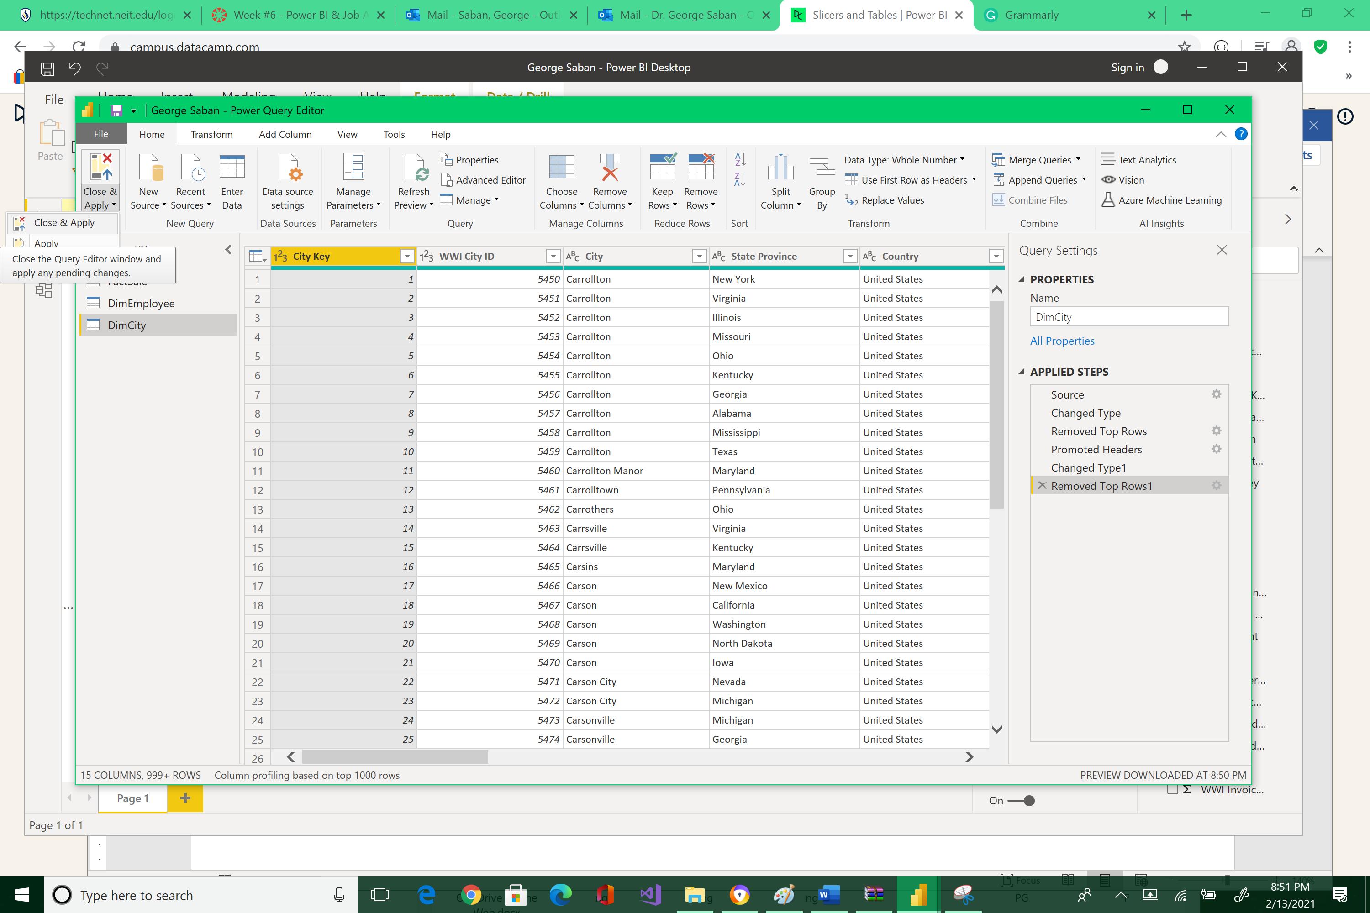



Go to Model view and observe how Power BI recognized that there is a relationship between FactSale and DimCity tables via City Key. The one-to-many connection was automatically made.

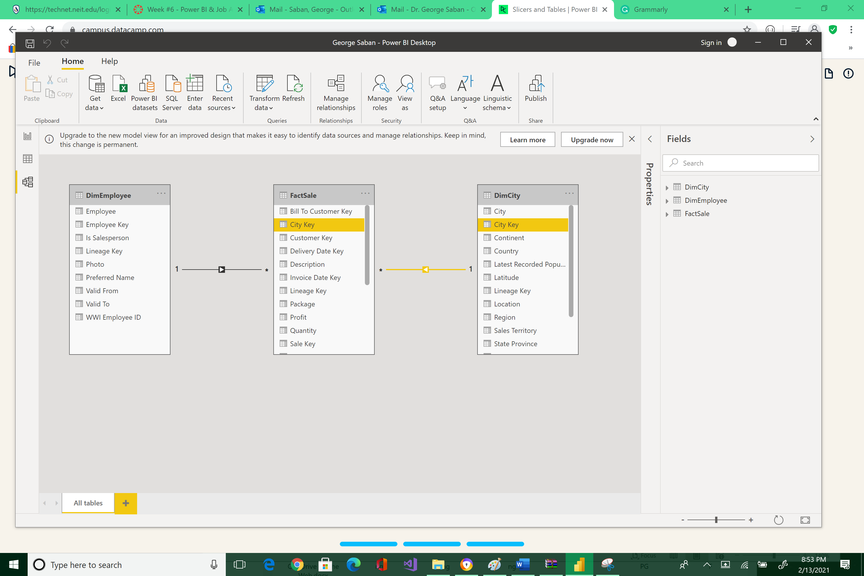



Go back to the Report view, unselect the graph by clicking on a white space of the Canvas, and then click Slicer.

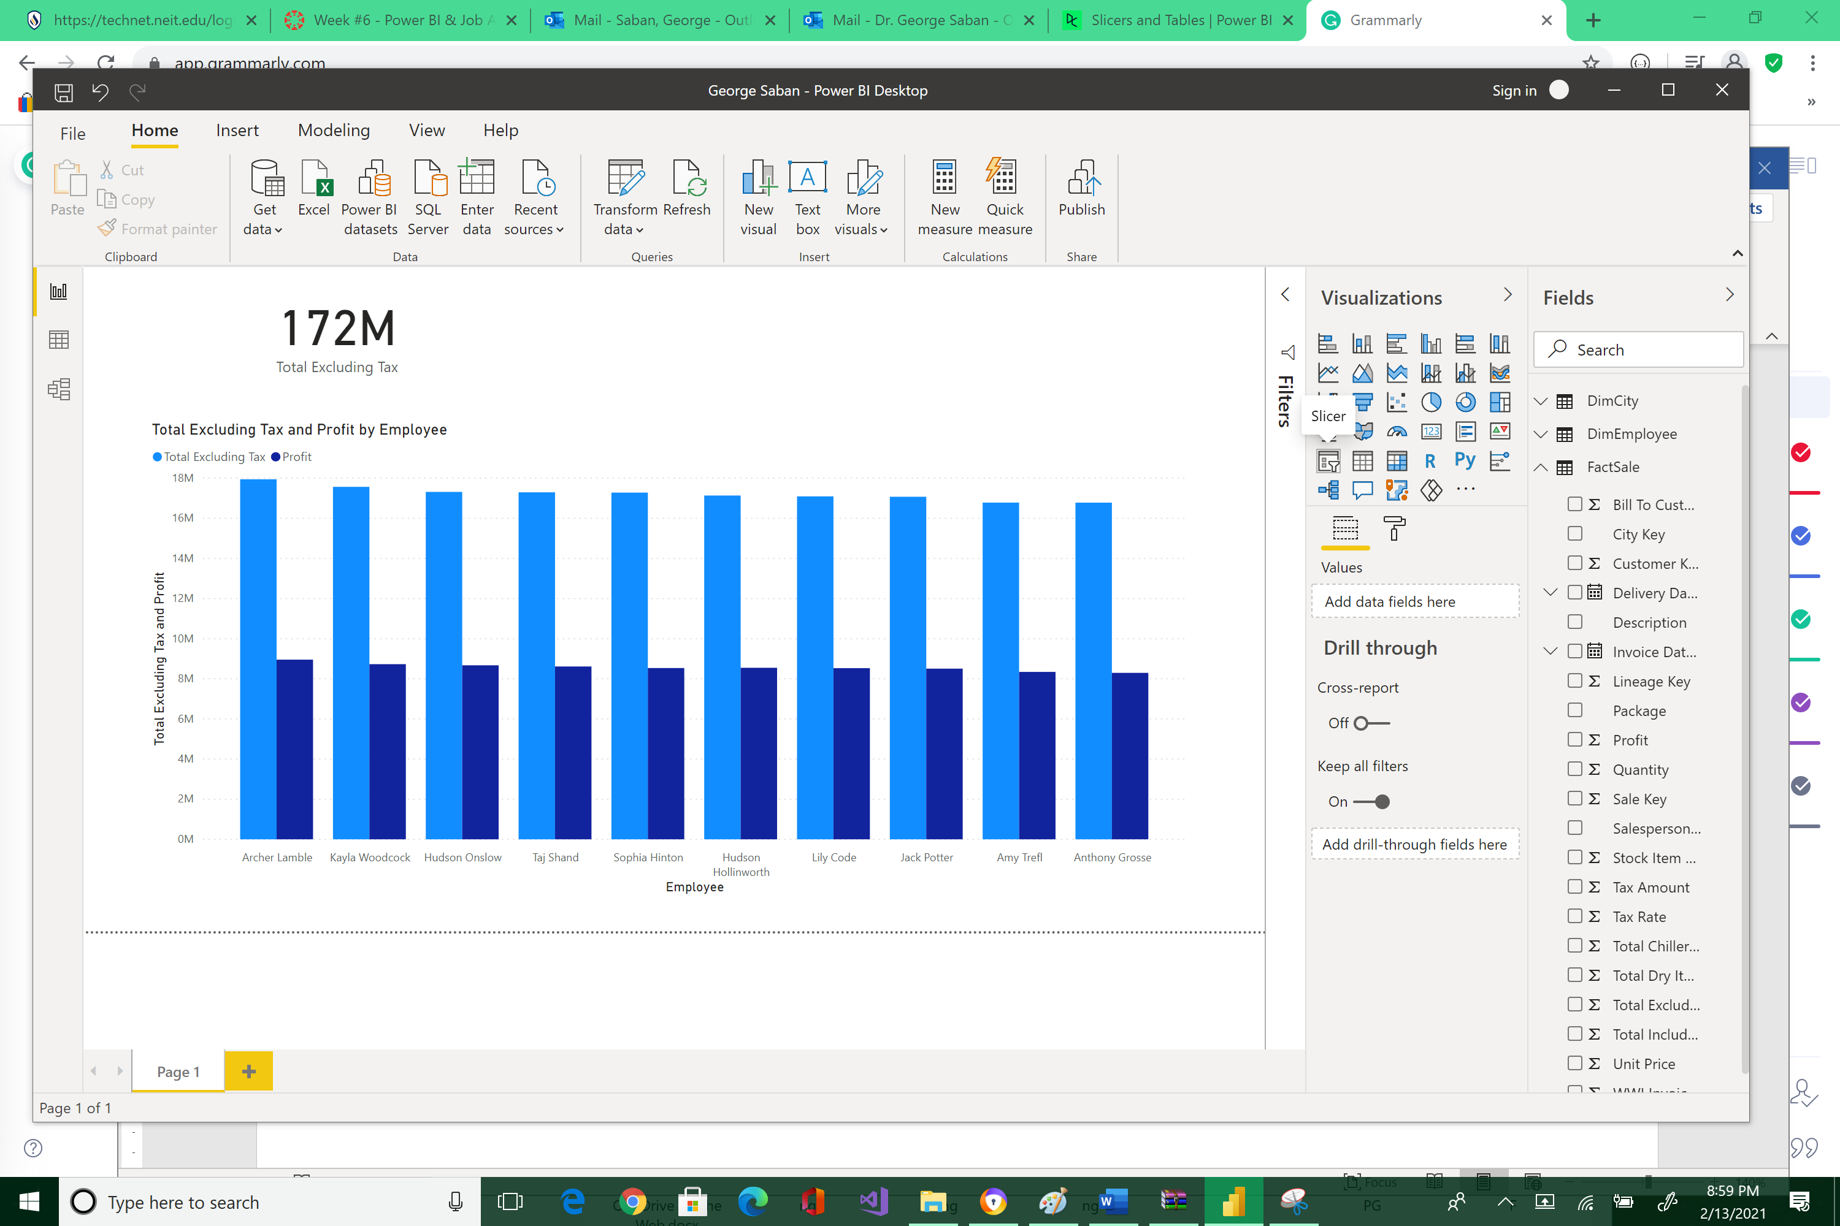



An empty Slicer widget is now displayed.

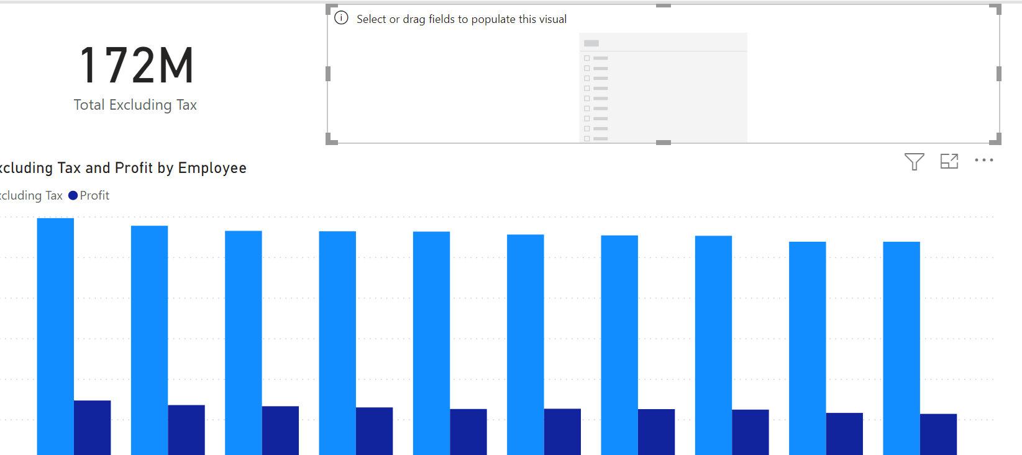



Select the sales territory field of DimCity table.

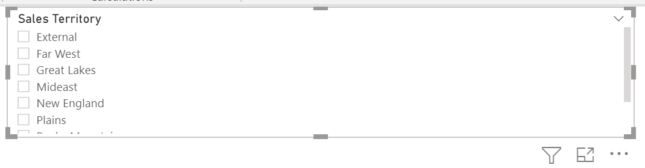 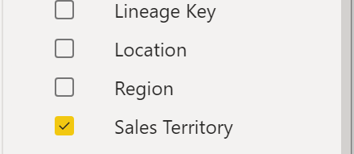



Reposition your visualization components so it will render like the image below.

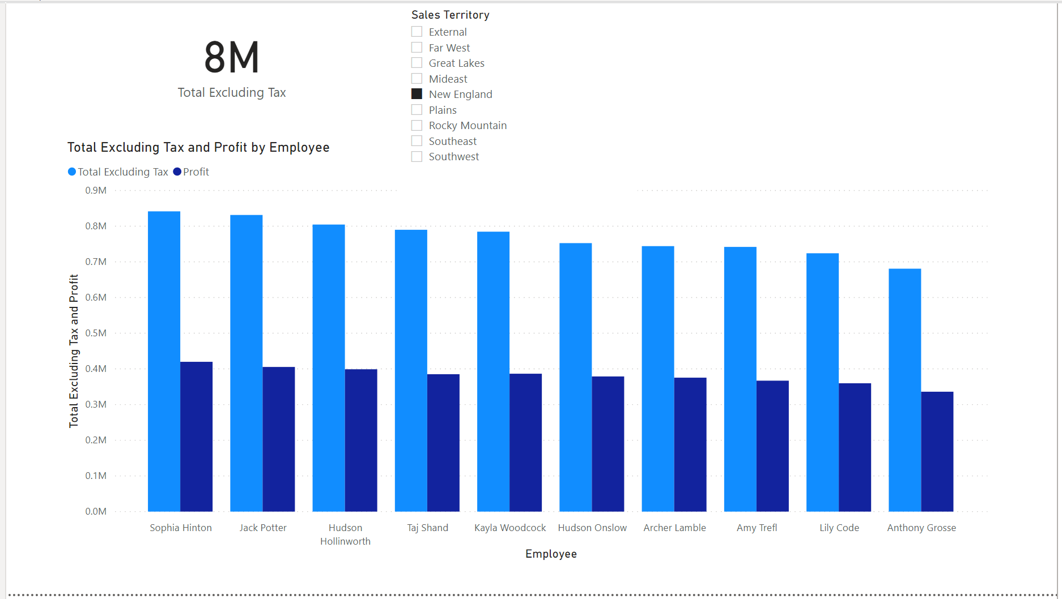

A Slicer allows viewers to filter by region. Click on the different Sales Territory check box inside the Slicer and watch how the Clustered Column chart changes. Now, add more visualization.

First click on a blank spot inside Canvas. There should be no visualization widget selected. Then select Table visualizer.

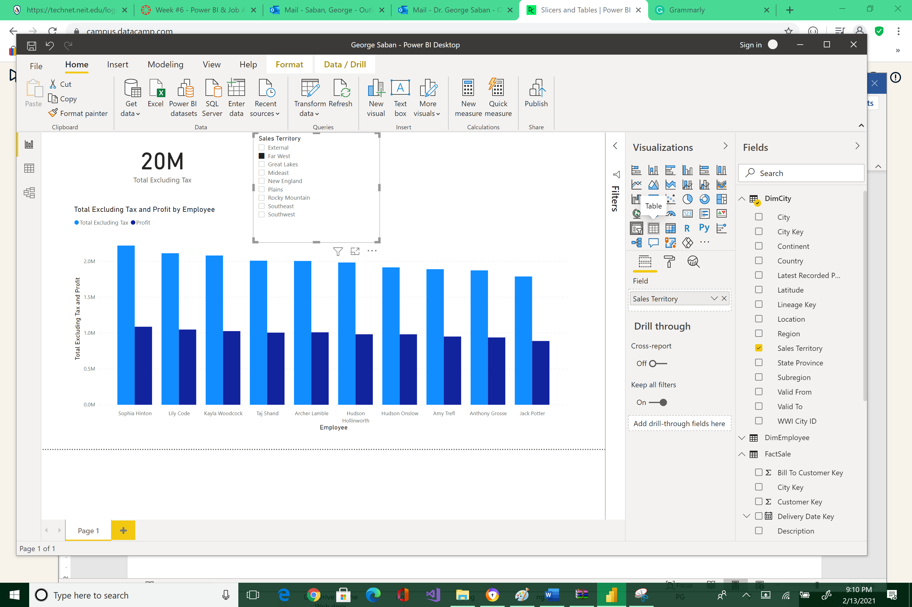



The Table object is now visible.

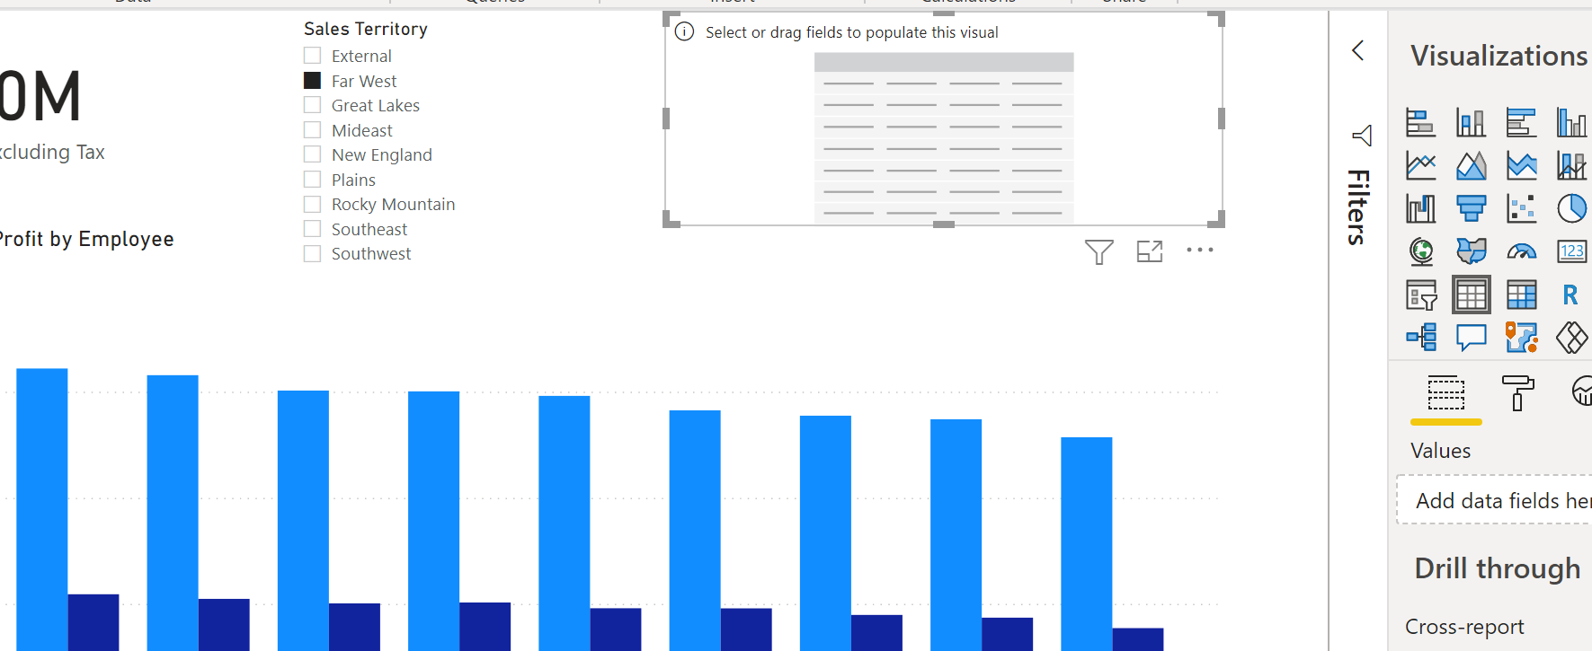



Now select a number of relevant fields from different tables to put inside this Table visualization component. While the Table is still enabled, select the following: Invoice Date Key, Employee, Total Excluding Tax, Tax Rate, Profit, City, and State Province.

Rearrange the Report to look nicer.

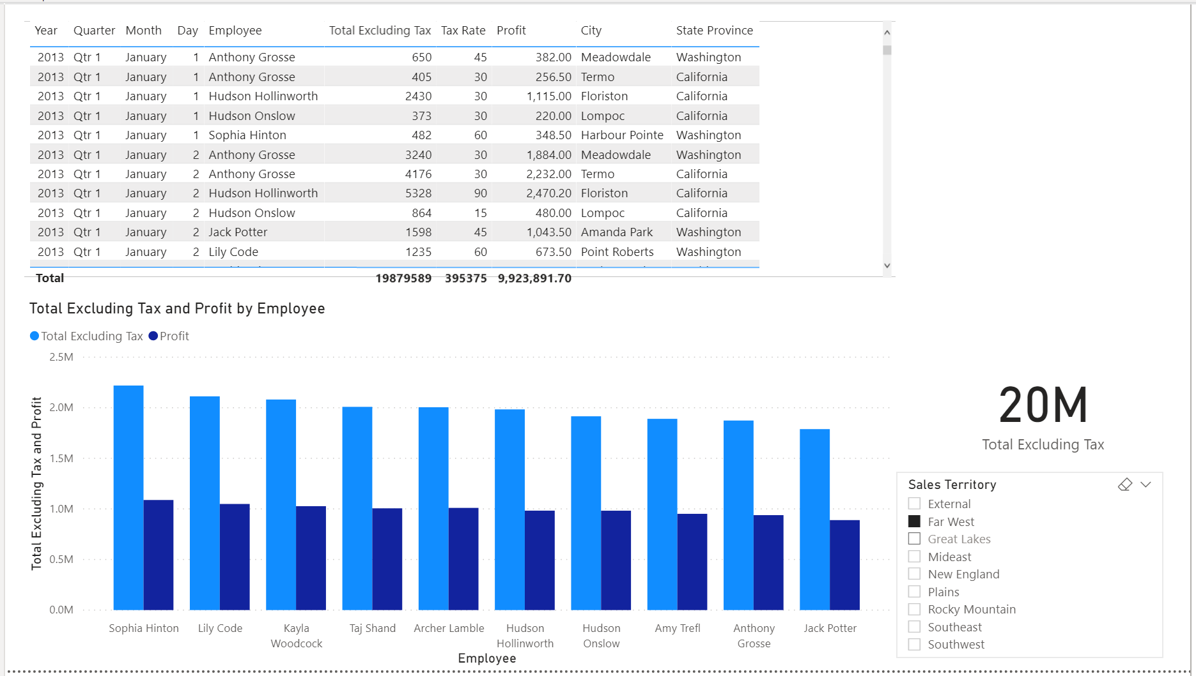

Clicking on any bar or Slicer’s check box will affect the Table and Card displays. How amazing is that! You can easily drag-and-drop visualization components and dynamically change the interface of the report.

Now, add a title using a text box.

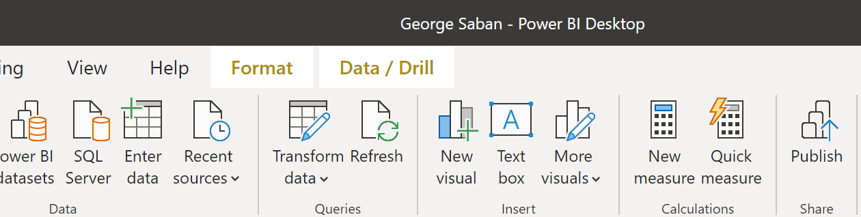



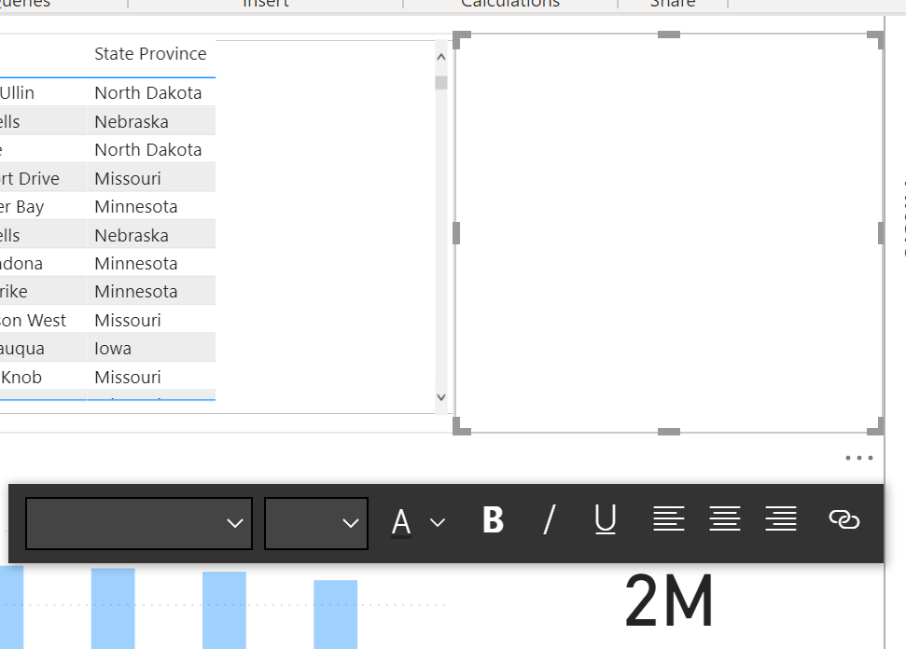



Type the following string as the title: “Employee Sales Data,” reformat, and rearrange.

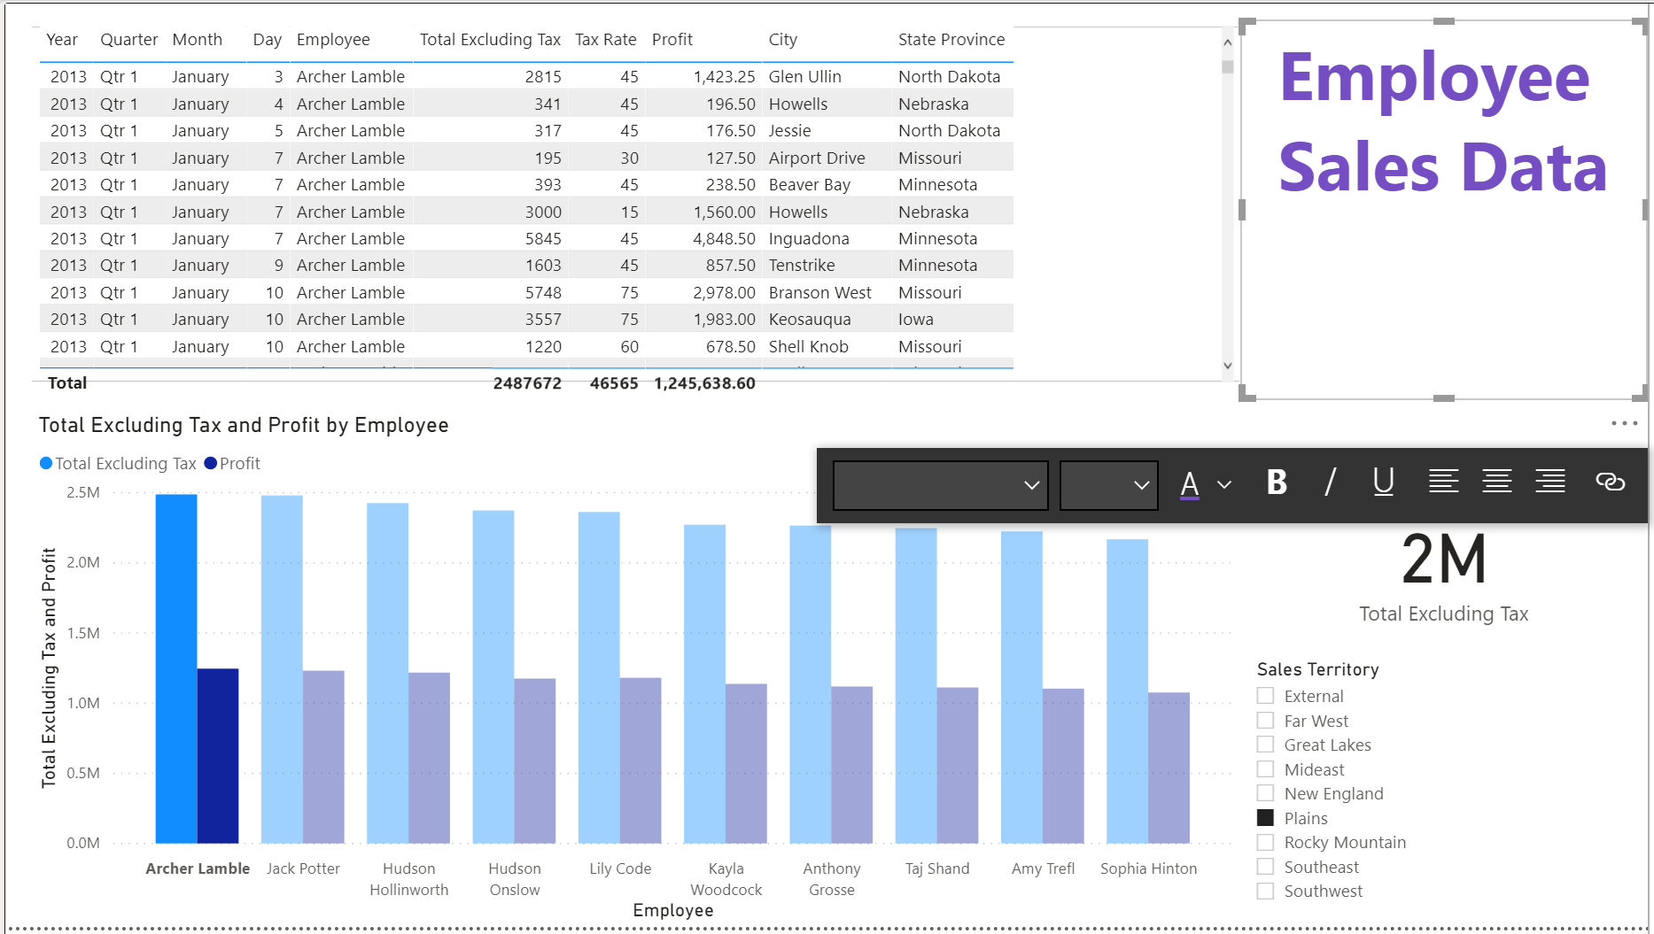

Also, change the tab label so it will match with the title. Right-click on the tab label > Rename Page.

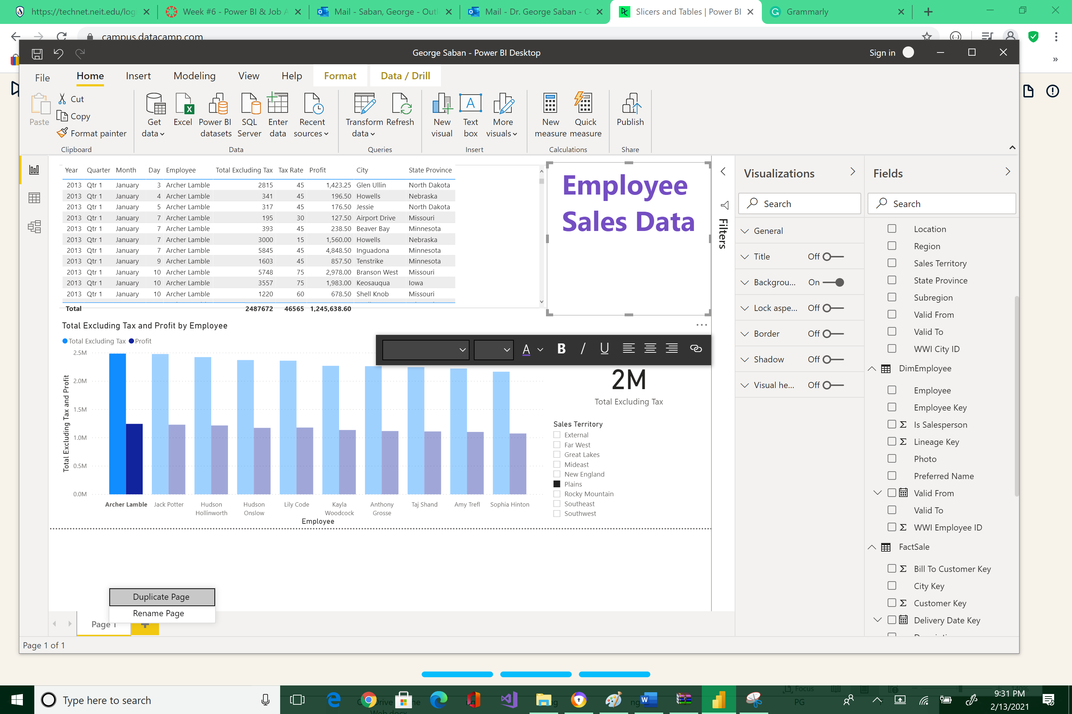



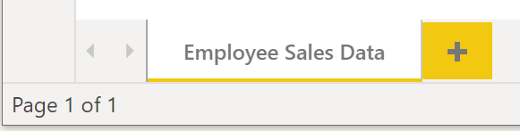

Please reposition your screen so that it would look like the image below. Take a snapshot using Window's Snipping Tool. Make sure the encircled items are included. Submit to Canvas in PNG format.  Thank you!

